Question 1: Output for a+b greater than c+d.

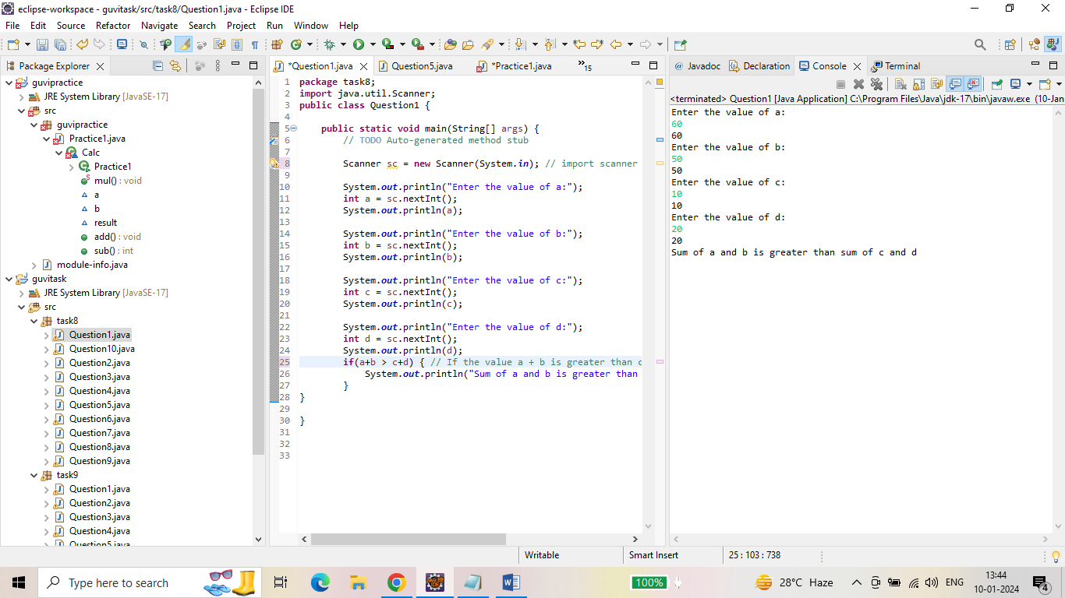

Question 2: output for checking weather the given num is even number or odd number.

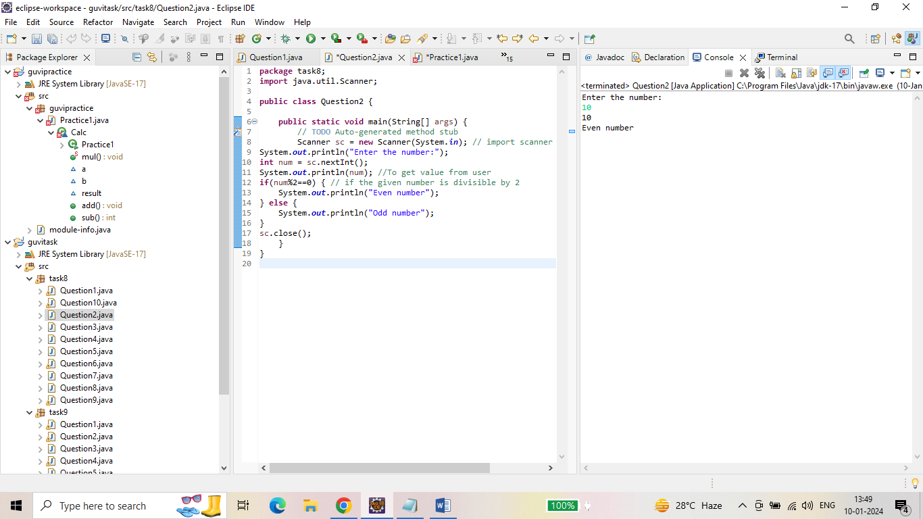

3. Output to print alphabets A - Z.

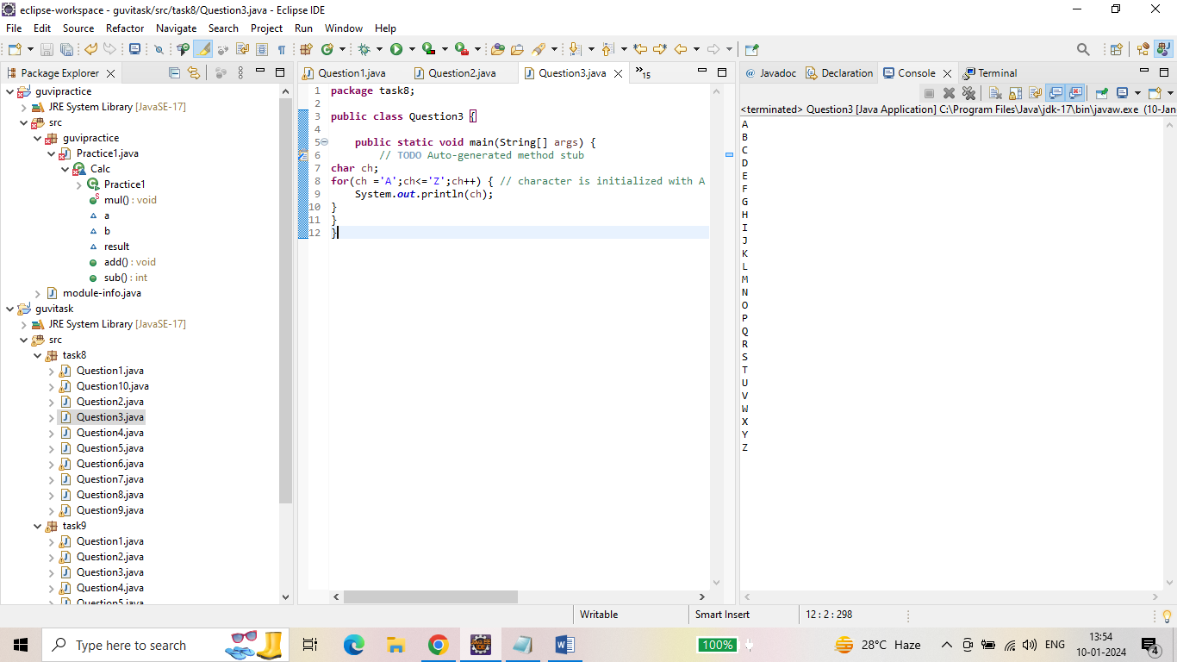

Question 4. Output for swapping two numbers.

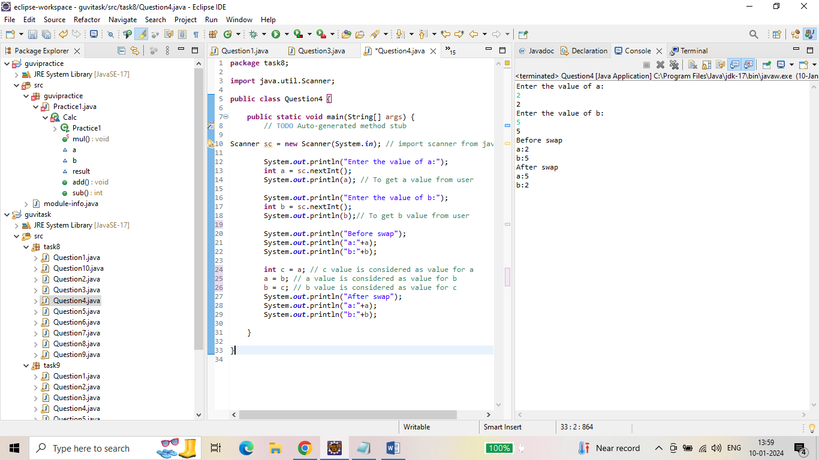

Question 5: Output for given number is prime or not

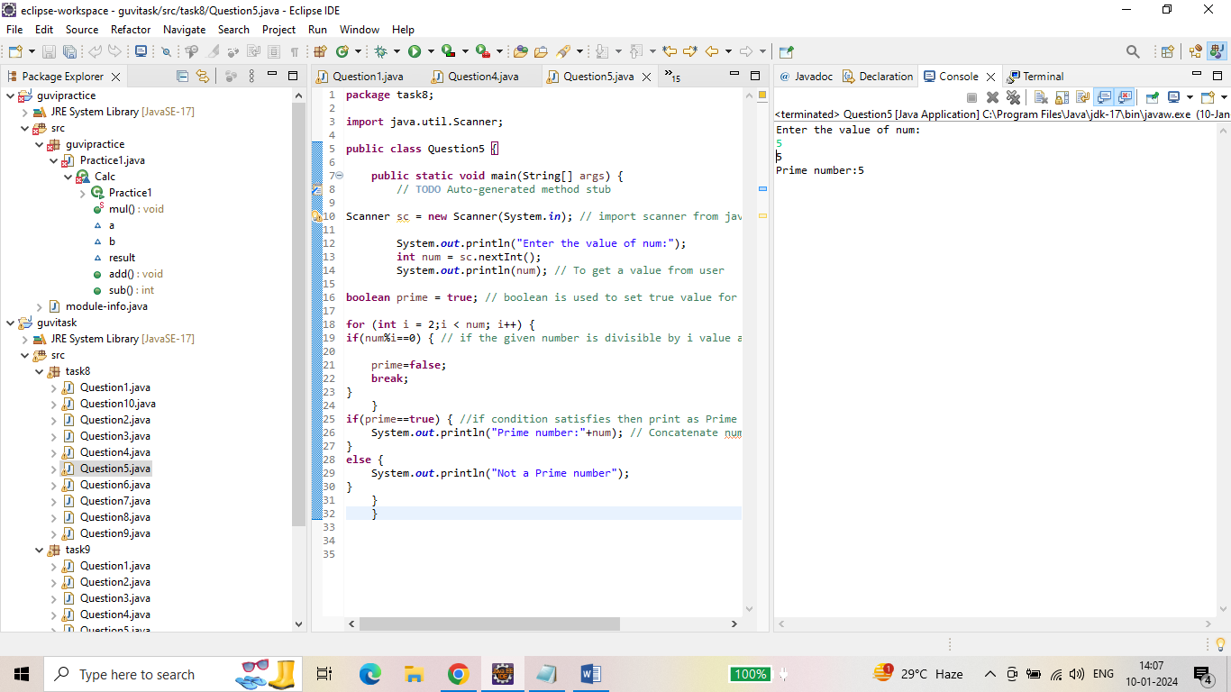

Question 6: Output for factorial of a given number.

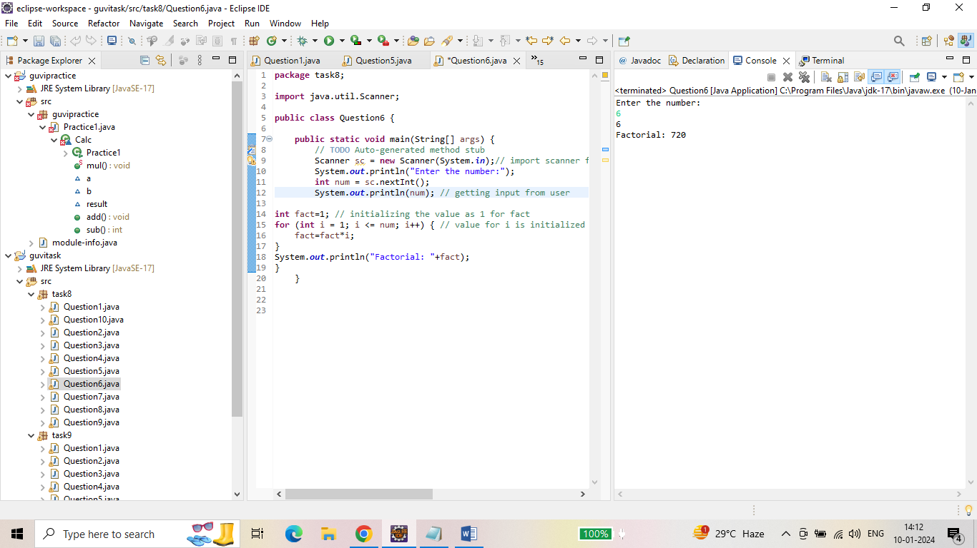

Question 7: Output for length of the given string.

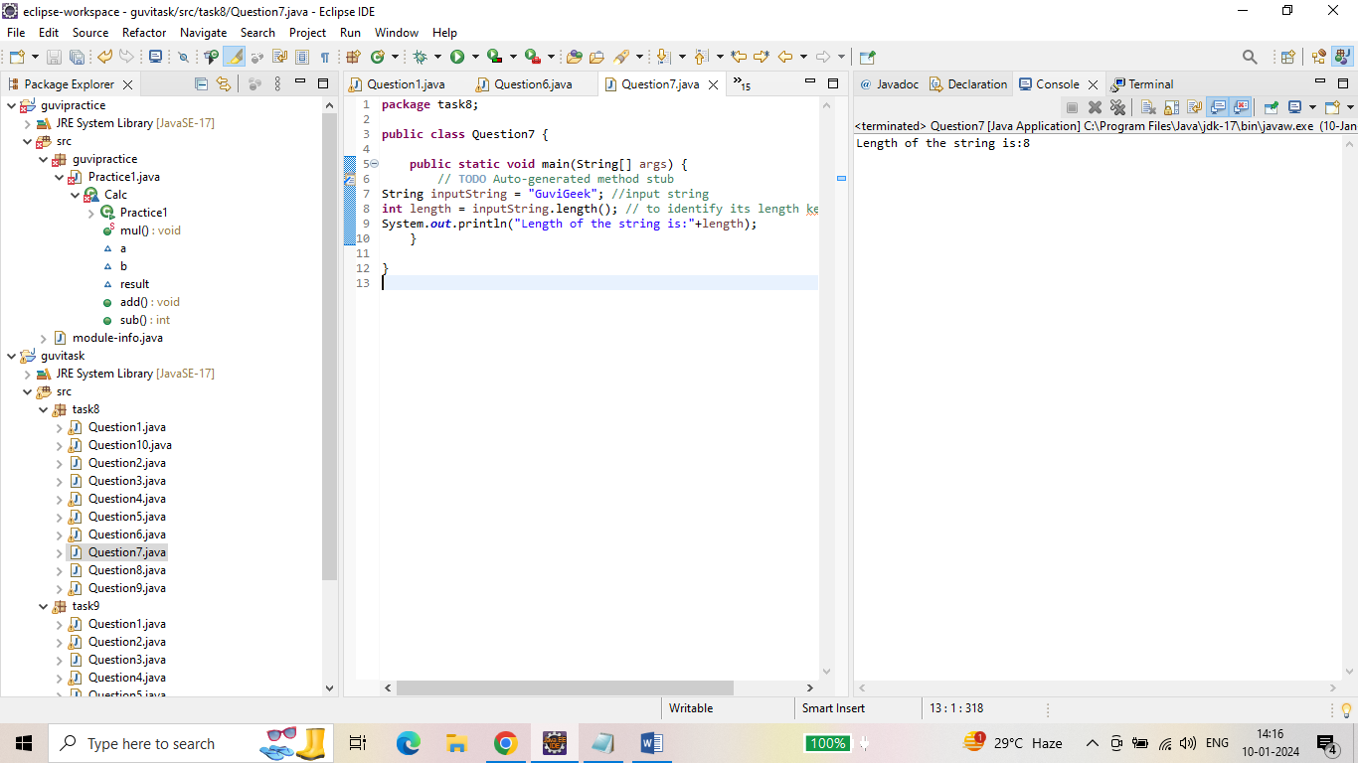

Question 8: Output for printing the given string for 10 times.

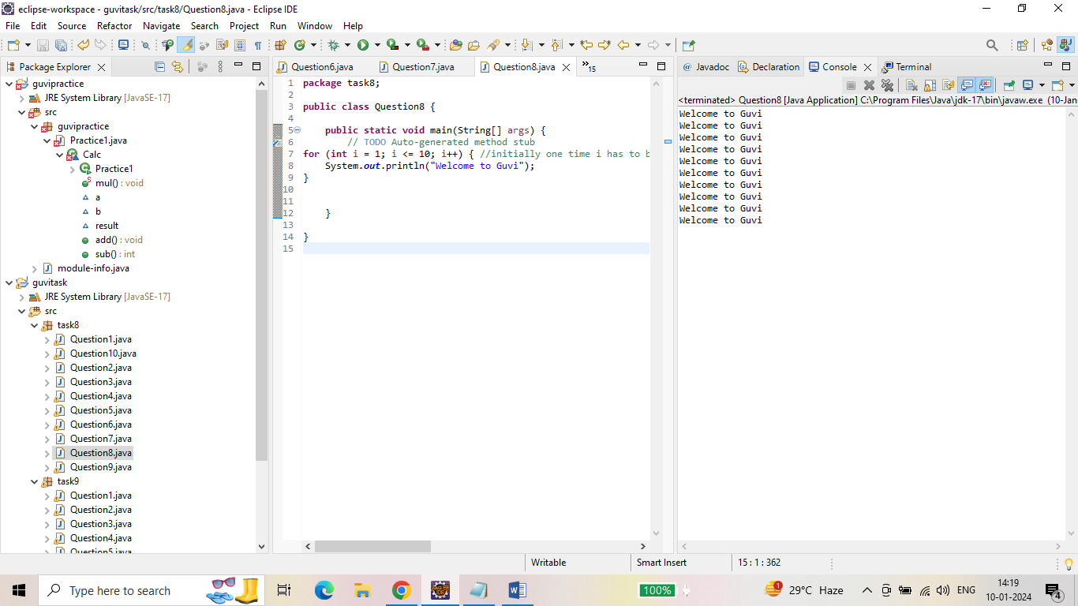

Question 9: Output to check weather the person is senior citizen or not.

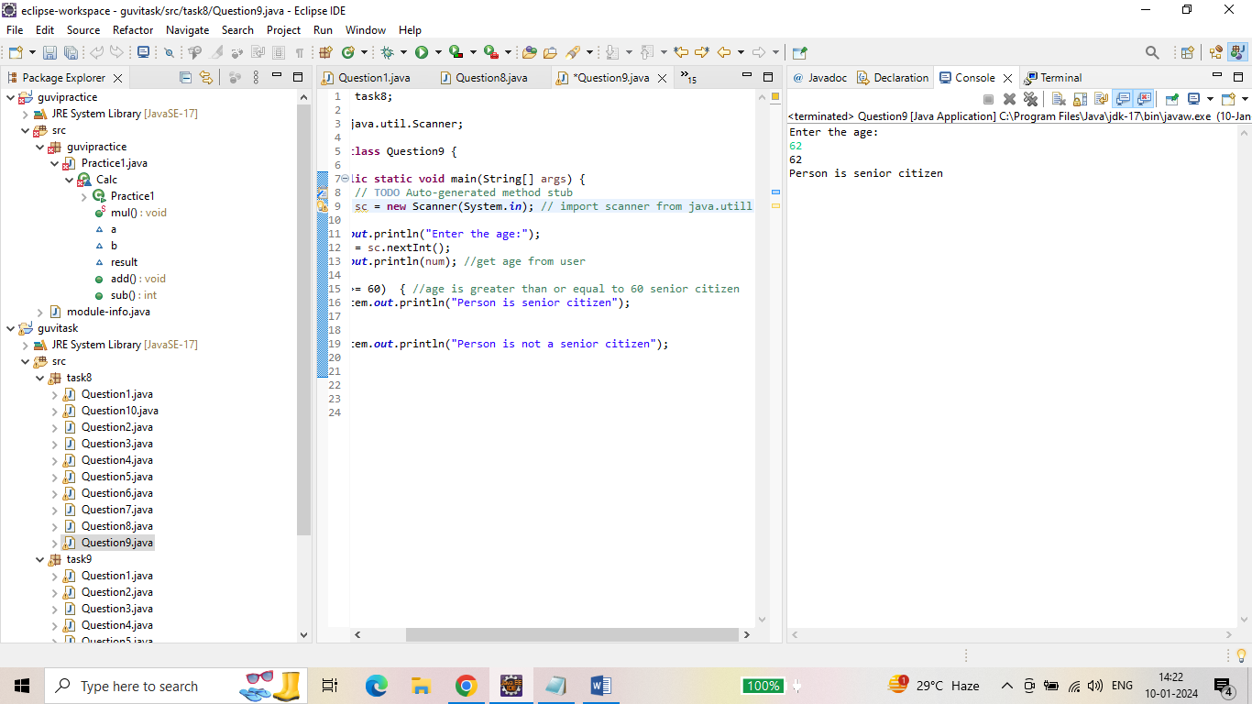

Question 10: Output to check number of digits in an integer.

